Using Quicknode

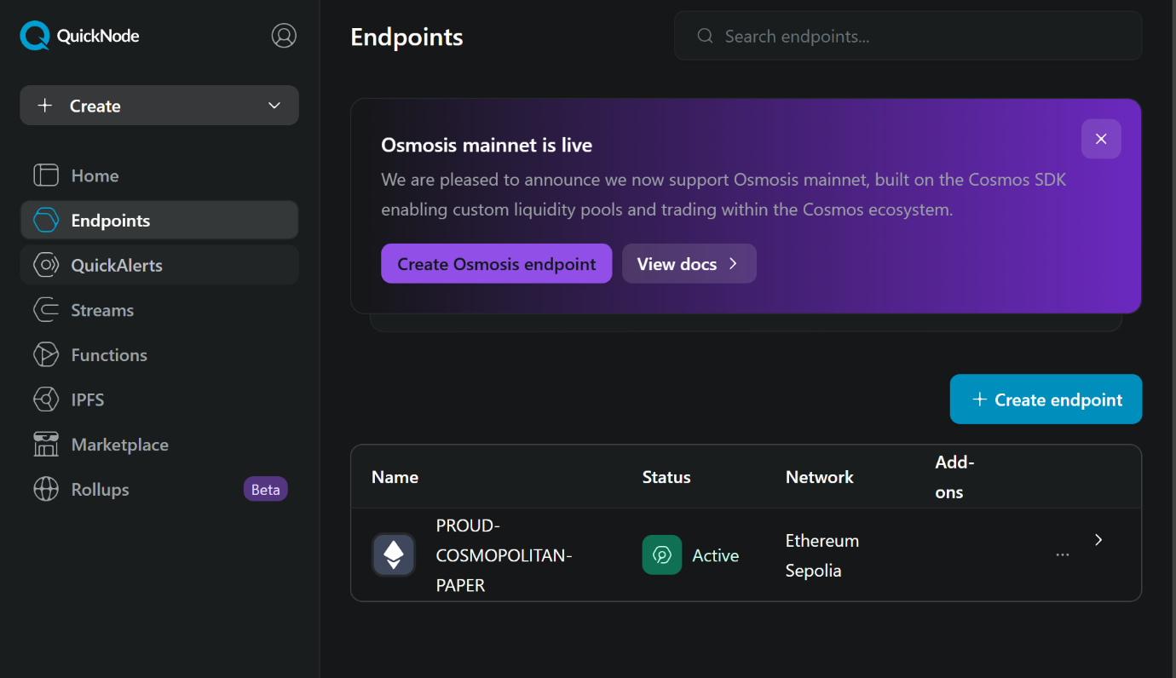Alchemy, Infura and many more offer nodes or you can run your own.

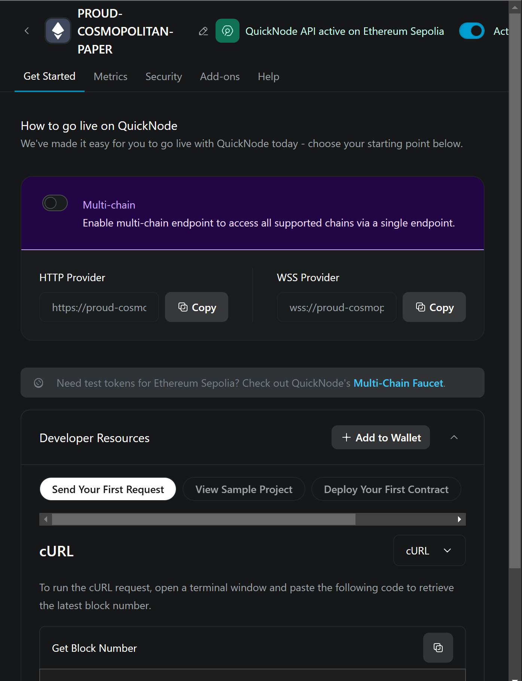  
I used Quicknode with their growth plan .  
To use Quicknode, create an endpoint for Sepolia Eth. You make can 1 for free as well.